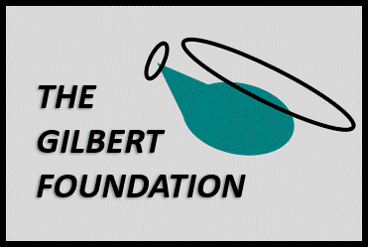 Grant Application Form

Date of Application:

PART I: Organizational Information

Contact Information
Legal Name of Organization (as shown on IRS Form 990):
Organization Address:

Website:
Chief Executive Officer, President or Executive Director:
Phone: E-mail:
Contact Person/Project Director:
Phone: Email:

General Information
Year Founded: Federal Tax ID #:
Geographic Area Served:
Number of People Served Annually:
Mission Statement:
Organization Budget
 | Current Year | Previous Year
Annual Operating Budget: | $ | $

Organization Personnel
 | Full-Time | Part-Time | Volunteer
Number of Employees:
Number of Directors on Board:

PART II: Project- or Program-Specific Information
Grant Amount Requested: $

Description
- Name of project or program:
- What need is addressed by this project/program, and what is its linkage to the goals of the organization?
- Who will benefit from this project/program?
- Are other groups providing similar services? Yes No If Yes, what distinguishes your project/program, or how does it complement others?

- Is this project/program being done in conjunction with (or in collaboration with) any other organization or non-profit group(s)? Yes No If Yes, please list:
- What is the timing for this project/program? Start Date: End Date:

Evaluation
Describe how you will assess the success and effectiveness of the project/program:

Funding
Total project/program cost: $ Percent of total cost represented by this grant request: %

List the funding from other private or public sources which have been received for this project, or which are under consideration:
Funding Source | Amount |  | Funding Source | Amount
 | $ |  |  | $
 | $ |  |  | $
 | $ |  |  | $

Are there matching or challenge grants associated with this project/program? Yes No If Yes, please describe:

Describe the plans for sustaining this project/program in future years (maintenance, etc.):

Certification

Signatory Officer (please type in name): Date:
Officer's position in the organization:

By submitting this application to The Gilbert Foundation, the grant-seeking organization certifies that it retains its public charitable status stated above, and further certifies that this status is not in danger of being revoked. In addition, the submittal of this application affirms that the grant-making organization has not received any goods or services in conjunction with this request, and that all information is correct to the best knowledge of the Signatory Officer.

Required Attachments

- IRS Letter of Determination
- Detailed budget for the project or program, including expenses and income
- List of Board members, titles, affiliations, phone numbers and compensation (if applicable)

NOTE: The IRS Form 990 for your organization will be downloaded by The Gilbert Foundation from www.guidestar.org. We do not need a soft copy of this document unless the version on guidestar.org is more than two years old.

Please return the completed form with attachments to candy@cgmedina.com

